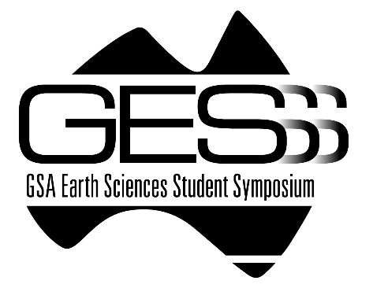
Details of Sponsorship
If your company or institute is interested in becoming a sponsor of GESSS XXX, please complete this form and return to the below email address by xxxdate. This information will be used to issue and invoice to your company/business or department.
Thank you for your contribution!
COMPANY/BUSINESS DETAILS
BUSINESS NAME: ___________________________________________________________________
BUSINESS ADDRESS: _________________________________________________________________
SUBURB, STATE, POSTCODE: __________________________________________________________
The Geological Society of Australia Inc (ABN: 93 652 757 443) will provide Tax Invoice and payment details.
YOUR DETAILS
Prof/Assoc. Prof/Dr/Mr/Ms/Mrs/Miss
NAME: ____________________________________________________________________________
POSITION: _________________________________________________________________________
PHONE: __________________________________ MOBILE: _________________________________
EMAIL: ____________________________________________________________________________

SPONSORSHIP
SPONSORSHIP PACKAGE: _____________________________________________________________
SPONSORED AMOUNT: (NUMERALS – INCLUDES GST) $ ____________________________________
SPONSORED AMOUNT: (WORDS – INCLUDES GST) $ _______________________________________
EMAIL ADDRESS OF GESSS COMMITTEE MEMBER:
INSERT NAME/EMAIL/CONTACT DETAILS
We look forward to working with you to promote your organisation to our attendees.

